WHO WE ARE
The Department carries out Management System Certification services as a third party Certification Body (CB) with accreditation to ISO/IEC 17021-1 for organizations seeking certification to management system standards. The scope of accreditation is ISO 9001. Accreditation is by Deutsche Akkreditierungsstelle GmbH (DAkkS), a German accreditation organization.
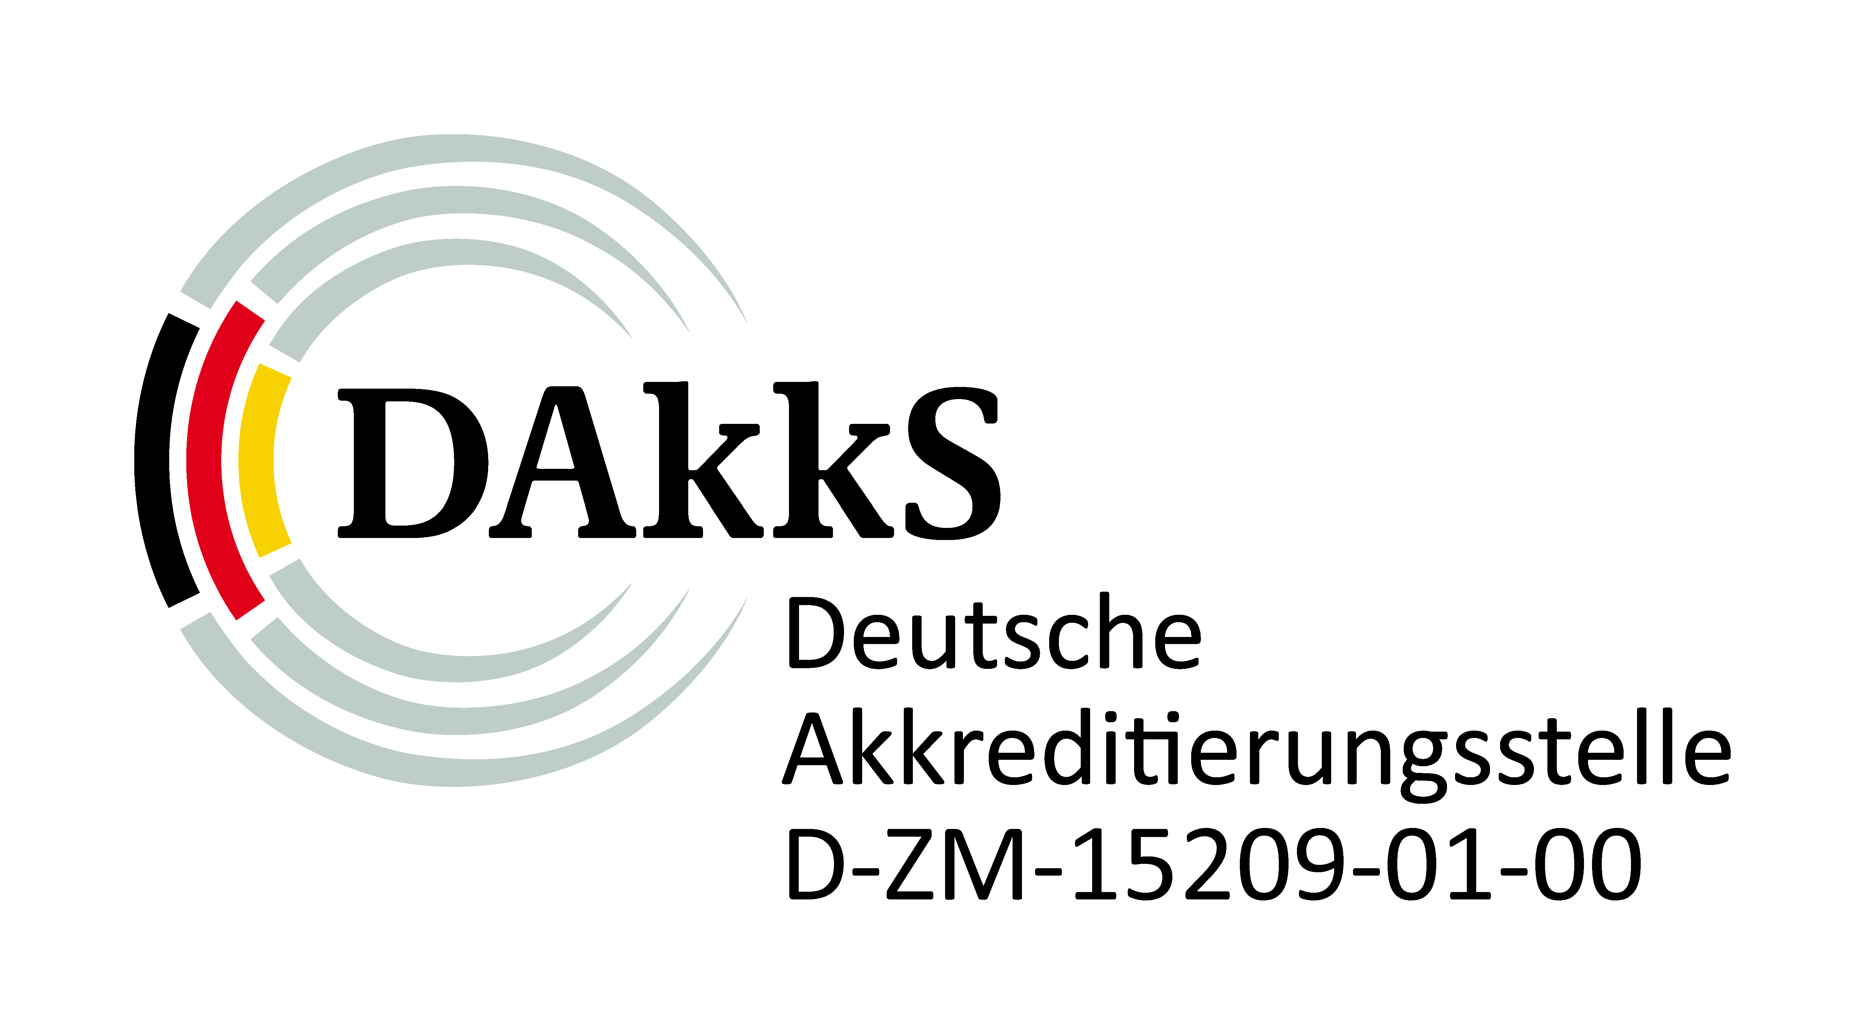
The scope of certification covers:
- ISO 9001 (Quality Management System)
- ISO 22000 (Food Safety Management System)
- Hazard Analysis & Critical Control Point (HACCP)
- ISO 14001 (Environmental Management System)
- OHSAS / ISO 45001 (Occupational Health and Safety Management Systems)
Companies, whose management system had been certified, provide products/services in the following areas:
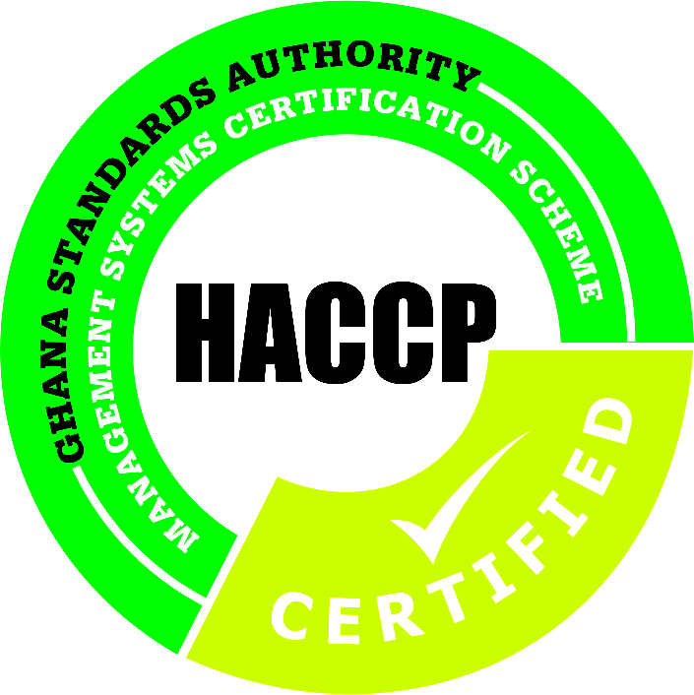
- Rubber & Plastics companies
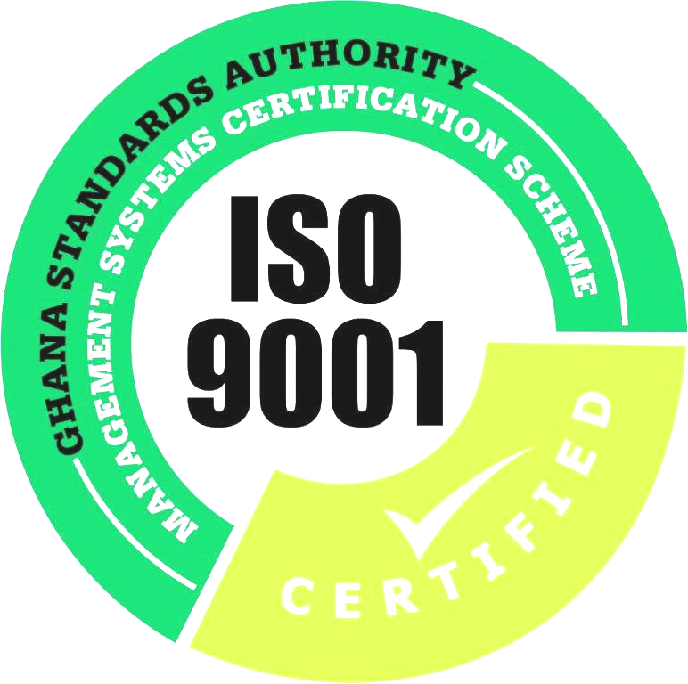
- Chemicals companies
- Management of waste of mining companies
- Oil marketing companies
- ICT solution providers
- Building & Construction Companies
- Food companies
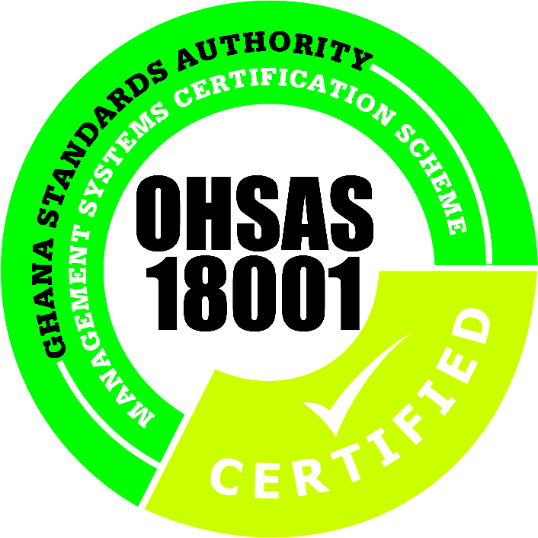
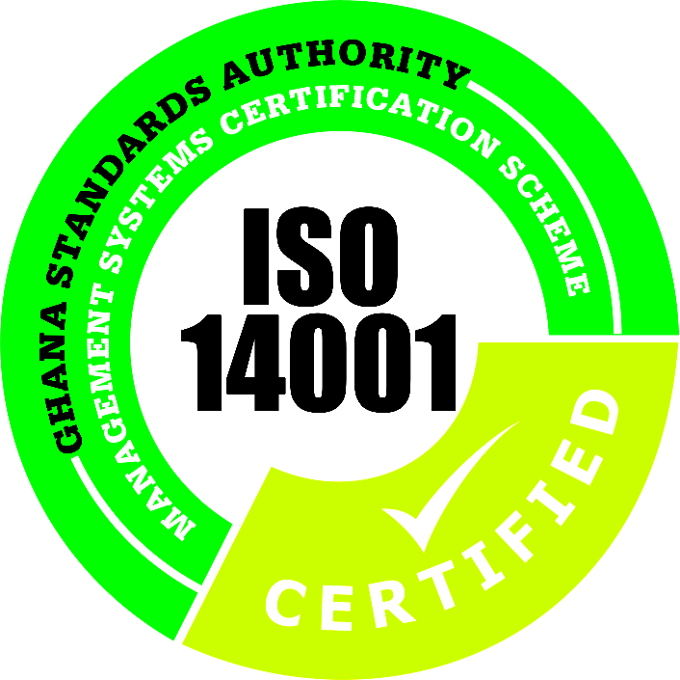
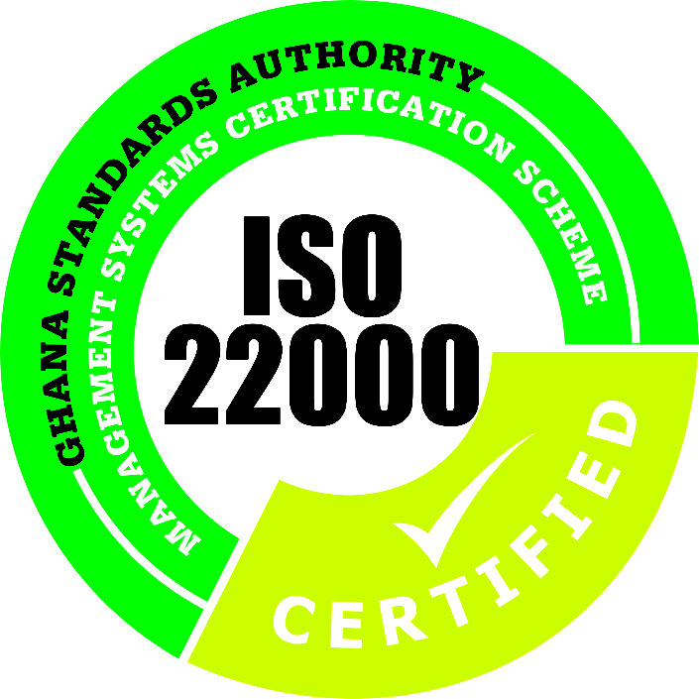

HOW TO GET CERTIFIED
STEP A - Submitted application is reviewed for adequacy. If adequate, GSA MSCS provides you with a contract based on the size and nature of your organization. We can then proceed with the audit after signing the contract.
STEP B
Pre-audit
[optional]
Certification cycle typically for 3 years
STEP A
Application
Application Review
Agree Contract
STEP C

Stage I Audit
STEP D

Stage II Audit
STEP E
Approval and Certificate Issue if successful Audit
STEP F

Surveillance
STEP G

Recertification Audit
Actions and Closures of Identified Non-Conformities
Certification cycle typically for 3 years
Certification cycle typically for 3 years
STEP B
Pre-audit
[optional]
STEP A
Application
Application Review
Agree Contract
STEP C

Stage I Audit
STEP D

Stage II Audit
STEP E
Approval and Certificate Issue if successful Audit
STEP F

Surveillance
STEP G

Recertification Audit
Actions and Closures of Identified Non-Conformities
STEP B
Pre-audit
[optional]
STEP A
Application
Application Review
Agree Contract
STEP C

Stage I Audit
STEP D

Stage II Audit
STEP E
Approval and Certificate Issue if successful Audit
STEP F

Surveillance
STEP G

Recertification Audit
Actions and Closures of Identified Non-Conformities

STEP B - GSA-MSCS may perform a ‘pre-audit’ to give an indication of your company’s readiness for the certification. This is optional. The pre-audit assessment is usually found useful in identifying any weaknesses and building confidence in your systems before the formal audit.

STEP C - The first part of the formal audit is the ‘Stage I. This evaluates the compliance of your documented system with the requirements of the applicable standard(s). This is to better understand the nature of your company, effectively plan the rest of the audit and examine key elements of your system. A report will be issued identifying any concerns or observations for immediate action.
STEP B
Pre-audit
[optional]

Certification cycle typically for 3 years

STEP A
Application receipt and review
Contract signing
STEP C
Stage I Audit
STEP D
Stage II Audit
STEP E
Approval and Certificate Issue if successful Audit
STEP F
Surveillance
STEP G
Recertification Audit
Actions and Closures of identified concerns & Non-Conformities

STEP D - This is ‘Stage II’ of the initial certification audit process. This audit involves interviews, examination of records, observation of working practices to determine how compliant your processes are with the standards and your own documentation system. The findings of the audit are classified as either major or minor non-conformances along with other observations and opportunities for improvement.

STEP E - Once you have addressed the non-conformities, a technical review of the audit reports will then be conducted by an Approval Committee to confirm the issuance of a certificate or not.

STEP F - Surveillance audits will be scheduled at eight to twelve month intervals after the initial certification depending on the contract. During the visits, we review the implementation of the action plan addressing the past non-conformities and examine certain mandatory and other selected parts of the system in line with an audit plan that is provided you before each visit.

STEP G - Before the third anniversary of the initial certification, our routine visit will be extended to enable a re-certification audit. Surveillance visits will then continue, as before, on a 3-year cycle
STEP B
Pre-audit
[optional]
Certification cycle typically for 3 years
STEP A
Application receipt and review
Contract signing
STEP C

Stage I Audit
STEP D

Stage II Audit
STEP E
Approval and Certificate Issue if successful Audit
STEP F

Surveillance
STEP G

Recertification Audit
Actions and Closures of Identified Non-Conformities
STEP B
Pre-audit
[optional]
Certification cycle typically for 3 years
STEP A
Application receipt and review
Contract signing
STEP C

Stage I Audit
STEP D

Stage II Audit
STEP E
Approval and Certificate Issue if successful Audit
STEP F

Surveillance
STEP G

Recertification Audit
Actions and Closures of Identified Non-Conformities
Certification cycle typically for 3 years
STEP B
Pre-audit
[optional]
Certification cycle typically for 3 years
STEP A
Application receipt and review
Contract signing
STEP C

Stage I Audit
STEP D

Stage II Audit
STEP E
Approval and Certificate Issue if successful Audit
STEP F

Surveillance
STEP G

Recertification Audit
Actions and Closures of Identified Non-Conformities
STEP B
Pre-audit
[optional]
Certification cycle typically for 3 years
STEP A
Application receipt and review
Contract signing
STEP C

Stage I Audit
STEP D

Stage II Audit
STEP E
Approval and Certificate Issue if successful Audit
STEP F

Surveillance
STEP G

Recertification Audit
Actions and Closures of Identified Non-Conformities
STEP B
Pre-audit
[optional]
Certification cycle typically for 3 years
STEP A
Application receipt and review
Contract signing
STEP C

Stage I Audit
STEP D

Stage II Audit
STEP E
Approval and Certificate Issue if successful Audit
STEP F

Surveillance
STEP G

Recertification Audit
Actions and Closures of Identified Non-Conformities
STEP B
Pre-audit
[optional]
Certification cycle typically for 3 years
STEP A
Application receipt and review
Contract signing
STEP C

Stage I Audit
STEP D

Stage II Audit
STEP E
Approval and Certificate Issue if successful Audit
STEP F

Surveillance
STEP G

Recertification Audit
Actions and Closures of Identified Non-Conformities
STEP B
Pre-audit
[optional]
STEP A
Application receipt and review
Contract signing
STEP C

Stage I Audit
STEP D

Stage II Audit
STEP E
Approval and Certificate Issue if successful Audit
STEP F

Surveillance
STEP G

Recertification Audit
Actions and Closures of Identified Non-Conformities

