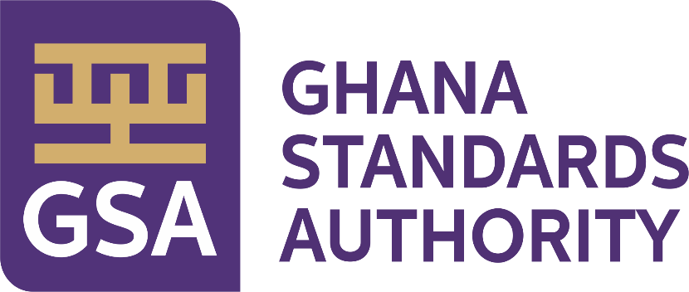

**Government of Ghana**

Right to Information Manual

Ghana Standards Authority (GSA)

2023

**Document Number: GSA/RTI/2023**

Table of Contents

**Table of Contents…………………………………………………………………………………..........i**

1. Overview 1

2. Directorates and Departments under Ghana Standards Authority (GSA) 2

2.1 Description of Activities of each Directorate and Department 4

2.2 Ghana Standards Authority’s Organogram 8

2.3 Classes and Types of information 9

3. Procedure in Applying and Processing Requests 10

3.1 The Application Process 10

3.2 Processing the Application 11

3.3 Response to Applicants 12

4. Amendment of Personal Record 13

4.1 How to apply for an Amendment 13

5. Appendix A: Standard RTI Request Form 14

6. Appendix B: Contact Details of GSA’s Information Unit 17

7. Appendix C: Acronyms 18

8. Appendix D: Glossary 19

## Overview

This Right to Information (RTI) Manual is pursuant to the provisions of the recently passed Act, (Act 989) by Parliament and assented to by the President, Nana Addo Dankwa Akuffo-Addo. The Act gives substance to the constitutional right to information provided under Article 21 (1) (f) of the Constitution, enabling citizens access to official information held by government institutions, and the qualifications and conditions under which the access may be obtained**.** In accordance with Section 80, the Act applies to information which came into existence before, or which will come into existence after the commencement of the Act.

**1.1 Purpose of Manual** – To inform/assist the public on the organizational structure, responsibilities and activities of the Ghana Standards Authority (GSA) and provide the types of information and classes of information available at GSA, including the location and contact details of its Information Officers and units.

## Directorates and Departments under Ghana Standards Authority (GSA)

This section describes the institution’s vision and mission and lists the names of all Directorates and Departments under the institution, including the description of organizational structure, responsibilities, details of activities and classes and types of information accessible at a fee.

**VISION**

To become a customer-focused world-class standards organization.

**MISSION**

To contribute towards the growth of industry, protect consumers and facilitate trade through Standardization, Metrology and Conformity Assessment.

|  |
| --- |
| **Directorates and Departments under Ghana Standards Authority** **(GSA)** |
| Standards Directorate  1. *Engineering, Building and Basic Standards Department*  *2. Food, Chemical and Material Standards Department*  *3. Technical Co-ordination Services Department*  Metrology Directorate  4. *Industrial Metrology Department*  *5. Legal Metrology Department*  *6. Scientific Metrology Department*  Planning, Monitoring and Evaluation Directorate  7. *Planning Department*  *8. Monitoring and Evaluation Department*  Testing Directorate(Biochemical Science and Physical Science)  *9. Food and Agriculture Department*  *10. Material Science Department*  *11. Engineering Department*  *12. Drugs, Cosmetics and Forensic Department*  *13. Microbiology Department*  *14. Laboratory Equipment Services Department*  Certification Directorate  *15.Product Certification Department*  *16. Systems Certification Department*  *17. Industrial Certification Department*  Inspectorate Directorate  *18. Import Inspection Department*  *19. Fish Inspection Department*  *20. Product Inspection Department*  Finance Directorate  *21. Finance Department*  *22. Accounts Department*  Administration Directorate  *23. Human Resource Department*  *24. Administration Department ( Facilities Unit, Transport Unit and Security Unit)*  Corporate Communications Directorate  *25. Marketing Department*  *26. Public Relations Department*  Procurement and Stores Directorate  *27. Procurement Department*  *28. Stores Unit*  Digital Transformation Directorate  *28. Information Technology Department*  General Directorate  *29. Legal Department*  *30. Audit Department*  *31. Business Development Department*  Regional Operations Directorate  *32. Regional Offices (Kumasi, Takoradi, Sunyani, Ho, Cape Coast, Tamale, Bolgatanga, Wa,Koforidua, Damongo, Naleregu, Techiman and Chacle Border Post)* |
| **Responsibilities of the Institution:**  Develops, Publishes and Promotes Standards in the country. |

### 2.1 Description of Activities of each Directorate and Department

|  |  |
| --- | --- |
| **Directorate/Department** | **Responsibilities/Activities** |
| ***Standards Directorate*** | ***Facilitates the development, Publishing and Promoting of Standards in accordance with the Standards Act of 1973 (NRCD 173).*** |
| Engineering, Building and Basic Standards | Development / Adoption and promotion of standards, codes of practice, Management Systems Standards,and related text on:  Electro-Technical Products (Electrical & Electronic products), Metrology and Measurement, Wood and Wood products, Building and General Construction, Oil and Gas, Automobile, Railway development, Telecommunication, Energy Management Systems, Waste Water Management Systems, Occupational Health and Safety, Mechanical Engineering and Metallurgy, Quality Management Systems and Renewable Energy. Secretariat to the IEC National Committee of Ghana. |
| Food, Chemicals and Material Standards | Development / Adoption and promotion of standards, codes of practice,Guidelines,Inspection, Manuals, Handbooks, Pictorials and related texts on:  Food Products, Agriculture Produce,Cosmetics,General and Households Chemicals,Medical Devices,Plastic and Plastic products,Paper and Paper products, Petroleum and Petroleum products,Packaging,materials,Textiles and Garments,Traditional Medicine,Tourism, Environmental Standards, Services Standards - Beauty and wellness, Leather and leather Products and Quality Management Systems Standards. |
| Technical Coordination Services | Documentation and Information Centre, Hub of all standards(National, Regional and International), Library Services, Sale of National, Regional and International Standards. Co-ordination of aspects of the standards development process, Management of the online Ghana Standards Catalogue. Managing and dissemination of information on Africa Continental Free Trade Area (AfCFTA) agreement, WTO, TBT and other Trade related information. Facilitate Ghana’s participation in Regional and International standardization activities, National Enquiry Point and National Notification Authority. Monitoring of National, Regional and International standards. |
| ***Metrology Directorate*** | ***Co-ordinates the Metrology activities of the Authority. This includes Industrial, Legal and Scientific Metrology Departments as well as Regional Metrology activities.*** |
| Industrial Metrology | Ensures calibration and verification of measurement instruments used in industry, production and testing processes to ensure consumer safety. It also organizes training workshops/seminars on measurements for industry with regards to the use and calibration of process control equipment. |
| Legal Metrology | Verifies the weights, measures, weighing and measuring instruments of corporate organizations and individuals as mandated by the Weights and Measures Decree, NRCD 326 of 1975 to ensure fair trading practices. It also organizes trading seminars annually for stakeholders to build their capacity on measurements and related subjects. |
| Scientific Metrology | It undertakes the calibration of laboratory, medical and other equipment across the country. The Department also registers all dealers in weights and measures conducting business in Ghana as mandated by the Weights and Measures Decree. |
| ***Planning, Monitoring and Evaluation Directorate*** | ***Coordinates activities of all functional areas to ensure that processes are established and followed to help improve performance and achieve results.*** |
| Monitoring and Evaluation Department | The Department undertakes Monitoring and Evaluation of the Authority’s operations to track and identify concerns of the directorates. |
| Planning Department | Provides data/information for effective evidence-based decision making and efficient management of resources for sustainable operation of the authority. |
| ***Testing Directorate*** | ***Coordinates testing activities of the departments under its juricsdiction. This is done through technical examination and analysis of goods/products according to specified procedure or test method*** |
| Food and Agriculture Department | Undertakes chemical, physical and organoleptic analysis on various food and agricultural products and produce including drinks to ascertain quality and level of compliance with applicable standards |
| Material Science Department | Undertakes physical tests and analyses on various products including general chemical based materials, water, textiles, paper, petroleum, precious metals and rubber products to ensure consumer safety. |
| Engineering Department | Undertakes physical and chemical tests on engineering products such as steel, roofing sheets, domestic utensils, machetes, gas cylinders Concrete cubes, sand/concrete blocks, electrical cables, refrigerating appliances, compact florescence lamps etc |
| Drugs, Cosmetics and Forensic Department | Undertakes tests and analysis on various products and samples for the purposes of quality, investigation and medical diagnoses. Eg are drugs, cosmetics, tissues, narcotics etc. |
| Microbiology Department | Undertakes microbiological analysis on food, water, cosmetics, drugs and other products such as sterilizers, water filters and nose masks etc. Tests are conducted to ascertain their safety and conformity to applicable standards. |
| Laboratory Equipment Services Department | Undertake routine maintenance as well as repairs of laboratory equipment to minimize the chance of breakdown during operations and to ensure continuous usage. It facilitates the development of analytical methods as well as issuance of technical specifications to user department. |
| ***Certification Directorate*** | ***Co-ordinates the activities of the Product, Systems and Industrial Support Departments.*** |
| Product Certification Department | Provides assessment and impartial third-party attestation that fulfillment of specified requirement has been demonstrated. |
| Systems Certification Department | Carries out management system certification services as a third party Certification Body with accreditation to ISO/IEC 17021-1 for organizations seeking certification to management system standards. |
| Industrial Support Department | Facilitates the provision of training to industry to enable GSA fulfill its mandate of promoting standardization for the improvement in the quality of goods, services and sound management , environmental and safety practices in industries and public institutions in Ghana. |
| ***Inspectorate Directorate*** | ***Coordinates and facilitates the Provision of inspection services to Manufacturing and Service Industries, Regulatory Bodies and the Private Sector to ensure consumer protection and trade facilitation*.** |
| Import Inspection Department | It undertakes the registration and inspection of imported High Risk Goods (HRGs) at designated entry points across the country to safeguard the health and safety of consumers as mandated by L.I 1541, (General Labelling Rules). It is to ensure that only imported products conforming to applicable Ghana Standards and Technical Regulations are allowed into the country. |
| Fish Inspection Department | Inspect and registers exporters of fish and fishery products, fishing vessels, fish processing plants, cold stores, ice-making plants and landing sites as a competent authority mandated by the European Union to ensure they meet requirements of their designated markets. |
| Product Inspection Department | The Product Inspection Department conducts inspection of factories, facilities, processes and products for export and certification. It is to ensure that Ghanaian products or consignments meant for export conform to the quality requirements of their designated markets as well as ensuring compliance to applicable Standards and Technical Regulations prior to the issuance of Certification licence. |
| ***Finance Directorate*** | Ensures the provision of efficient financial support to the operations of the Authority in line with the existing legislation of the state and best professional practices. |
| Finance Department | Ensure the provision of services geared towards ensuring sound and efficient Financial Management activities to sustain the Authority financially. It provides services such as preparation of annual financial statements and preparation of financial and management reports. |
| Accounts Department | Facilitates the processing and payment of employees’ compensation, management of accounts receivables and payables, assets and stock management to ensure sound and efficient management of the Authority’s finances. |
| ***Administration Directorate*** | ***Coordinates and facilitates enhancement and development of the human resource capital for the realization of the overall goal of the Authority.*** |
| Administration Department | Facilitates activities of the Security, Transport and Facilities Units respectively which includes the provision of safe and reliable vehicular support, maintenance of all offices equipment and facilities and adequate security for both employees and clients. |
| Human Resource Department | It is responsible for the enhancement and development of the Authority’s human resource capital, as well as meeting the human resource needs of the Authority by facilitating recruitment and hiring of productive work force reflective of the Authority’s diversity |
| ***Procurement and Stores Directorate*** | ***Oversees the judicious use of the resources of the Authority through the procurement of goods and services as well efficient management of stocks.*** |
| Procurement Department | The Department secures the judicious, economic and efficient use of the Authority’s resources in its procurement activities to ensure that procurement is carried out in a fair, transparent and non-discriminatory manner |
| Stores Unit | The Stores collaborates with the procurement department to procure quality goods and services in accordance with the Public Procurement ACT. It also oversees the efficient management (receipt and disposal) of stocks of the Authority. |
| ***Digital Transformation Directorate*** | ***Responsible for ensuring the availability of modern information technology infrastructure for efficient operation of the Authority.*** |
| Information Technology Department | Undertakes routine maintenance of the Authority’s Information Technology System to facilitate the Authority’s operations. It provides hardware and software assistance and guidance to GSA staff to ensure effective and efficient delivery of their functions. |
| ***General Directorate*** | ***Coordinates the activities of the Legal, Audit and Public Relations departments to facilitate effective decision making and visibility of the Authority’s operations at all levels*** |
| Legal Department | The Legal Department of the Authority provides legal services in the area of drafting and review of Contracts, Agreements and documents. It also facilitates the gazetting of Ghana Standards in the Ghana Gazette including the provision of General Legal advice to the Authority to aid informed decision making |
| Audit Department | The Audit Department provides the needed internal audit functions to facilitate sound, effective and informed decision making by management of the Authority. It also conducts Operational and Management audits on the operations of the Authority to complement the financial gains of the Authority |
| Business Development Department | The department performs functions ranging from enforcement of GSA’s mandate on the domestic market, project planning and management, marketing and promotion of GSA activities, evaluation of current business processes and maintaining strategic business relationships with both private and public institutions amongst others. |
| ***Corporate Communications Directorate*** | ***It ensures the provision of comprehensive public relations and marketing support services to improve customer satisfaction, visibility and effective public education on Standardization, Metrology and Conformity Assessment.*** |
| Public Relations Department | To promote the activities and operations of the authority, using all available communication channels, providing relevant information internally and externally. |
| Marketing Department | The Marketing Department provides excellent customer service, and innovative marketing strategy for result-oriented management of the Authority. This includes sensitizing businesses on the benefits of standards and related activities, brand awareness on Standards, Metrology and Conformity Assessment. |
| ***Regional Operations Directorate*** | ***The Directorate facilitates the operations and activities of all the Regional Offices to effectively and efficiently execute the Authority’s mandate at the Regional Level and ensure visibility*** |

### 2.2 Ghana Standards Authority’s Organogram

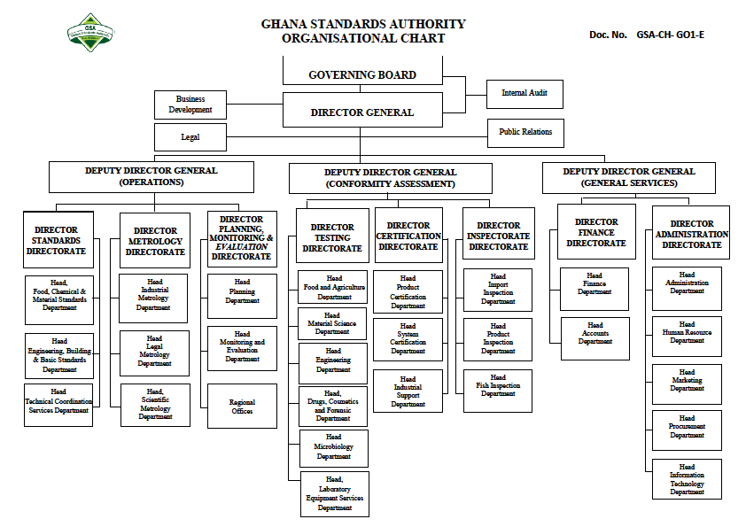

**Doc. No. GSA-CH- GO1-E**

### 2.3 Classes and Types of information

|  |
| --- |
| **List of various classes of information in the custody of Ghana Standards Authority:** |
| 1. Financial Reports. 2. Employee Personal Information. 3. Inspection Reports. 4. Certification Reports. 5. Standards Information. 6. Metrology Information. 7. Testing Reports. |
| **Types of Information Accessible at a fee:** |
| Not Available. |

## Procedure in Applying and Processing Requests

Section 18 of the RTI Act provides specific guidelines for application for access to information kept by a public institution. It is thus important that request for information is made in accordance with provisions under this Act. The Information Officer or a designated officer is responsible for dealing with applications made to the Ghana Standards Authority. To requests for information under the RTI Act from the Ghana Standards Authority, applicants are to follow these basic procedures:

### 3.1 The Application Process

1. Application by any person or organization who seeks access to information in the custody of Ghana Standards Authority must be made in writing, using the standard RTI Application Form. (**See** **Appendix A** **for the Standard RTI Application Form**). A copy of the form can be downloaded or completed and submitted electronically on the Ghana Standards Authority’s official website or the Ministry of Information website.
2. In making the request, the following information must be provided:

* Date of the Application.
* Name of the applicant or the person on whose behalf an application is being made.
* Name of the organization represented by the applicant.
* Available contact details of the applicant or address of the person/organization on whose behalf an application is being made (Telephone Number, Email, Postal Address, Fax).
* Brief description of information being sought. (Applicants are to specify the class and type of information including cover dates).
* Payment of relevant fee if applicable.
* Signature/ thumbprint.

1. Provision of identification

The applicant must present at least one (1) of the following valid identification cards (IDs) to serve as proof of identity:

* Driver’s License.
* Passport.
* National ID.
* Voter’s ID.

1. The applicant should state the format of information being requested and the mode of transmission. Example (do you need certified true copy, normal photocopy or electronic copies. Would you want to receive it through a postal address, e-mail, courier services, fax etc.?)
2. Where an applicant cannot write due to illiteracy or a disability, he/she may make the request orally. However, oral request must conform to the following guidelines;

* The Information Officer must reduce the oral request into writing and give a copy of the written request as recorded for the applicant to authenticate. (s. 18) (3).
* The Information Officer shall clearly and correctly read and explain the written request to the understanding of the applicant.
* A witness must endorse the face of the request with the writing*;* ***“****the request was read to the applicant in the language the applicant understand and the applicant understand the content of the request.”*
* The applicant must then make a thumbprint or mark on the request.

### 3.2 Processing the Application

* Applications would be treated on a priority basis. The Information Officer is responsible for handling requests to ensure that statutory deadlines are met.
* Reviews and identify which part is exempt based on Sections 5 to 16 of the RTI Act and determines which of the units in the institution have the records or is responsible for the subject matter of the request.
* Provision is made under section 20 for the transfer of an application within a period of not more than ten days of receipt where the public institution to which the application was initially made is unable to deal with the application. In such situations, applicants would be notified accordingly with the reasons and dates of transfer.
* For information readily available in official publications, the Information Officer shall direct the applicant to the institution having custody of that publication and notify the public institution of the request. (s.21).
* If a requested information is not readily accessible, the estimated time it will take to search for the information would be communicated to the applicant.

### 3.3 Response to Applicants

1. The Information Officer is required under section 23 of the RTI Act to notify applicants within fourteen (14) days from the date of receipt. Applicants should however note that the time limit does not apply to applications transferred to another public institution or which has been refused due to failure to pay prescribed deposit or fee. (s.23) (6). The notice should state:

* Whether or not full access to the requested information will be granted or only a part can be given and the reason for that decision.
* The format and mode of access.
* The expected publication or submission day of the information in the case of a deferred access.
* The prescribed fee (s.24).

b. The Information Officer can request an extension to the deadline if:

* Information requested is voluminous.
* It is necessary to search through a large number of records.
* The information has to be gathered from more than one source.
* Consultation with someone outside the institution is required.

c. The Information Officer would in such situations notify applicants of an extension as well as the period and reason for the extension. An extension should not be more than seven days.

d. In giving applicants access to information, the applicant would be given the opportunity to inspect the information or receive a copy physically or any other form required such as electronic, magnetic, optical or otherwise, including a computer print-out, various computer storage devices and web portals.

* Where access cannot be given in the form specified by the applicant, access can be given in some other form. In such cases, the applicant shall be provided with a reason why access cannot be given in the specified form.

## Amendment of Personal Record

A person given access to information contained in records of a public institution may apply for an amendment of the information if the information represents the personal records of that person and in the person’s opinion, the information is incorrect, misleading, incomplete or out of date.

### 4.1 How to apply for an Amendment

1. The application should be in writing indicating;

* Name and proof of identity.
* Particulars that will enable the records of the public institution identify the applicant.
* The incorrect, misleading, incomplete or the out of date information in the record.
* Signature of the applicant.

1. For incomplete information claimed or out of date records, the application should be accompanied with the relevant information which the applicant considers necessary to complete the records.
2. The address to which a notice shall be sent should be indicated.
3. The application can then be submitted at the office of the public institution.

## Appendix A: Standard RTI Request Form

|  |  |  |  |  |  |  |  |  |
| --- | --- | --- | --- | --- | --- | --- | --- | --- |
| [Reference No.: ………………………….]  ­­­APPLICATION FOR ACCESS TO INFORMATION UNDER THE RIGHT TO INFORMATION ACT, 2019 (ACT 989) | | | | | | | | |
|  | **Name of Applicant:** | |  | | | | | |
| 2. | **Date:** | |  | | | | | |
| 3. | **­Name of Institution:** | |  | | | | | |
| 4. | **Date of Birth:** | | **DD** | | | **MM** | | **YYYY** |
| 5. | **Type of Applicant:** | | **Individual Organization/Institution** | | | | | |
| 6. | **Tax Identification Number** | | | |  | | | |
| 7. | **If Represented, Name of Person Being Represented:** | | | | |  | | |
| 7 (a). | **Capacity of Representative:** | | | | |  | | |
| 8. | **Type of Identification: National ID Card Passport Voter’s ID**  **Driver’s License** | | | | | | | |
| 8 (a). | **Id. No.:** |  | | | | | | |
| 9. | **Description of the Information being sought (specify the type and class of information including cover dates. Kindly fill multiple applications for multiple requests):** | | | | | | | |
| 10. | **Manner of Access:** | | | **Inspection of Information**  **Copy of Information**  **Viewing / Listen**  **Written Transcript**  **Translated (specify language)** | | | | |
| 10 (a). | **Form of Access:** | | | **Hard copy Electronic copy Braille** | | | | |
| 11. | **Contact Details:** | | | **Email Address__________________________________**  **Postal Address_________________________________**  **Tel:** _________________________________________ | | | | |
| 12. | **Applicant’s signature/thumbprint:** | | | | | |  | |
| 13. | **Signature of Witness (where applicable)**  ***“This request was read to the applicant in the language the applicant understands and the applicant appeared to have understood the content of the request.”*** | | | | | |  | |

## Appendix B: Contact Details of GSA’s Information Unit

**Name of Information/Designated Officer:**

Kofi Yeboah Debrah

**Telephone/Mobile number of Information Unit:**

0242177775

**Email:**

**Postal Address of the institution:**

P. O. Box MB 245 Accra.

## Appendix C: Acronyms

Table 1 Acronyms

| Acronym | Literal Translation |
| --- | --- |
| RTI | Right to Information |
| MDA | Ministries, Departments and Agencies |
| s. | section |
| MMDAs | Metropolitan, Municipal and District Assemblies |
| GSA | Ghana Standards Authority |
| IEC | International Electrotechnical Commission |
| ISO | International Organization for Standardization |
| NRCD | National Redemption Council Decree |

## Appendix D: Glossary

This Glossary presents clear and concise definitions for terms used in this manual that may be unfamiliar to readers listed in alphabetical order. Definitions for terms are based on section 84 of the RTI Act.

Table 2 Glossary

| **Term** | **Definition** |
| --- | --- |
| Access | Right to Information |
| Access to information | Right to obtain information from public institutions |
| Contact details | Information by which an applicant and an Information Officer may be contacted |
| Court | A court of competent jurisdiction |
| Designated officer | An officer designated for the purposes of the Act who perform similar role as the Information Officer |
| Exempt information | Information which falls within any of the exemptions specified in sections 5 to 16 of the Act |
| Function | Powers and duties |
| Government | Any authority by which the executive authority of the Republic of Ghana is duly exercised |
| Information | *Information according to the Act includes recorded matter or material regardless of form or medium in the possession or under the control or custody of a public institution whether or not it was created by the public institution, and in the case of a private body, relates to the performance of a public function.* |
| Information officer | *The information officer of a public institution or the officer designated to whom an application is made* |
| Public | *Used throughout this document to refer to a person who requires and/or has acquired access to information.* |
| Public institution | *Includes a private institution or organization that receives public resources or provides a public function* |
| Right to information | *The right assigned to access information* |
| Section | *Different parts of the RTI Act* |