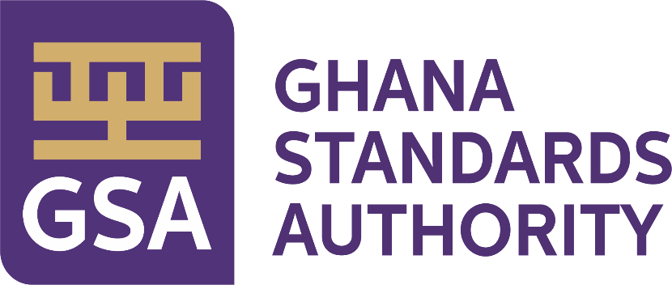

Right to Information Manual

Ghana Standards Authority (GSA)

2026
Document Number: GSA/RTI/2026

Table of Contents
Table of Contents…………………………………………………………………………………..........i
1. Overview 1
2. Directorates and Departments under Ghana Standards Authority (GSA) 2
2.1 Description of Activities of each Directorate and Department 4
2.2 Ghana Standards Authority’s Organogram 11
2.3 Classes and Types of information 12
3. Procedure in Applying and Processing Requests 13
3.1 The Application Process 13
3.2 Processing the Application 14
3.3 Response to Applicants 15
4. Amendment of Personal Record 17
4.1 How to apply for an Amendment 17
5. Appendix A: Standard RTI Request Form 18
6. Appendix B: Contact Details of GSA’s Information Unit 21
7. Appendix C: Acronyms 22
8. Fees and Charges……………………………………………………………………………….......
9. Appendix D: Glossary 124

Overview
This Right to Information (RTI) Manual is pursuant to the provisions of the passed Act, (Act 989) by Parliament. The Act gives substance to the constitutional right to information provided under Article 21 (1) (f) of the Constitution, enabling citizens access to official information held by government institutions, and the qualifications and conditions under which the access may be obtained. In accordance with Section 80, the Act applies to information which came into existence before, or which will come into existence after the commencement of the Act.

1.1 Purpose of Manual – To inform/assist the public on the organizational structure, responsibilities and activities of the Ghana Standards Authority (GSA) and provide the types of information and classes of information available at GSA, including the location and contact details of its Information Officer and RTI unit.

Directorates and Departments under Ghana Standards Authority (GSA)
This section describes the vision and mission of Ghana Standards Authority and lists the names of all Directorates and Departments under the institution, including the description of organizational structure, responsibilities, details of activities and classes and types of information accessible at a fee.
VISION
To become a customer-focused world-class standards organization.
MISSION
To contribute towards the growth of industry, protect consumers and facilitate trade through Standardization, Metrology and Conformity Assessment.
Directorates, Departments and Units under Ghana Standards Authority (GSA)
Standards Directorate
1. Engineering, Building and Basic Standards Department
2. Food, Chemical and Material Standards Department
3. Technical Co-ordination Services Department
Metrology Directorate
4. Industrial Metrology Department
5. Legal Metrology Department
6. Scientific Metrology Department
Policy, Planning, Monitoring and Evaluation Directorate
7. Planning Department
8. Monitoring and Evaluation Department
9. Regional Offices
Testing Directorate
10. Microbiology Department
11. Drugs, Cosmetics and Forensics Department
12. Food and Agriculture Department
13. Engineering
14. Polymer and Composite Materials Laboratories
15. Petrochemical & Industrial Laboratories
Certification Directorate
16.Product Certification Department
17. Systems Certification Department
18. Industrial Support Department
19. Vehicle Homologation Unit
Inspectorate Directorate
20. Import Inspection Department
21. Fish Inspection Department
22. Product Inspection Department
Finance Directorate
23. Accounts Department
24. Cost & Budgeting Department
Administration & HR Directorate
25. Administration Department
26. Human Resource Department
27. Information Technology Department
28. Procurement Department
29. Marketing Department
General Directorate (Deputy Director Generals Secretariats)
30. Legal Services
31. Public Relations
32. Internal Audit
Responsibilities of the Institution:
Develops, Publishes and Promotes Standards in the country.

2.1 Description of Activities of each Directorate and Department

Directorate/Department | Responsibilities/Activities
Standards Directorate | Facilitates the development, Publishing and Promoting of Standards in accordance with the GSA Act, 2022 (ACT 1078)
Engineering, Building and Basic Standards | Development / Adoption and promotion of standards, codes of practice, Management Systems Standards,and related text on:  Electro-Technical Products (Electrical & Electronic products), Metrology and Measurement, Wood and Wood products, Building and General Construction, Oil and Gas, Automobile, Railway development, Telecommunication, Energy Management Systems, Waste Water Management Systems, Occupational Health and Safety, Mechanical Engineering and Metallurgy, Quality Management Systems and Renewable Energy. Secretariat to the IEC National Committee of Ghana.
Food, Chemicals and Material Standards | Development / Adoption and promotion of standards, codes of practice,Guidelines,Inspection, Manuals, Handbooks, Pictorials and related texts on:  Food Products, Agriculture Produce,Cosmetics,General and Households Chemicals,Medical Devices,Plastic and Plastic products,Paper and Paper products, Petroleum and Petroleum products,Packaging,materials,Textiles and Garments,Traditional Medicine,Tourism, Environmental Standards, Services Standards - Beauty and wellness, Leather and leather Products and Quality Management Systems Standards.
Technical Coordination Services | Documentation and Information Centre, Hub of all standards(National, Regional and International), Library Services, Sale of National, Regional and International Standards. Co-ordination of aspects of the standards development process, Management of the online Ghana Standards Catalogue. Managing and dissemination of information on Africa Continental Free Trade Area (AfCFTA) agreement, WTO, TBT and other Trade related information. Facilitate Ghana’s participation in Regional and International standardization activities, National Enquiry Point and National Notification Authority. Monitoring of National, Regional and International standards.
Metrology Directorate | Co-ordinates the Metrology activities of the Authority. This includes Industrial, Legal and Scientific Metrology Departments as well as Regional Metrology activities.
Industrial Metrology | Ensures calibration and verification of measurement instruments used in industry, production and testing processes to ensure consumer safety. It also organizes training workshops/seminars on measurements for industry with regards to the use and calibration of process control equipment.
Legal Metrology | Verifies the weights, measures, weighing and measuring instruments of corporate organizations and individuals as mandated by the GSA Act, 2022 (Act 1078) Section 54 - 58 (Weights and Measures for Trade, Industry, Health, Safety and Environment) and Section 59 – 64 (Administration of Weights and Measures) to ensure fair trading practices. It also organizes trading seminars annually for stakeholders to build their capacity on measurements and related subjects.
Scientific Metrology | It undertakes the calibration of laboratory, medical and other equipment across the country. The Department also registers all dealers in weights and measures conducting business in Ghana as mandated by the Weights and Measures Decree.
Planning, Planning, Monitoring and Evaluation Directorate | Coordinates activities of all functional areas to ensure that processes are established and followed to help improve performance and achieve results.
Monitoring and Evaluation Department | The Department undertakes Monitoring and Evaluation of the Authority’s operations to track progress of work and identify concerns of the directorates.
Planning Department | Provides data/information for effective evidence-based decision making and efficient management of resources for sustainable operation of the authority.
Regional Offices | They facilitate the activities of the authority of all regional offices to effectively and efficiently execute the Authority’s mandate at the regional level and ensure visibility.
Testing Directorate | Coordinates testing activities of the departments under its juricsdiction. This is done through technical examination and analysis of goods/products according to specified procedure or test method.
Food and Agriculture Department | Undertakes chemical, physical and organoleptic analysis on various food and agricultural products and produce including drinks to ascertain quality and level of compliance with applicable standards.
Drugs, Cosmetics and Forensic Department | Undertakes tests and analysis on various products and samples for the purposes of quality, investigation and medical diagnoses. Eg are drugs, cosmetics, tissues, narcotics etc.
Microbiology Department | Undertakes microbiological analysis on food, water, cosmetics, drugs and other products such as sterilizers, water filters and nose masks etc. Tests are conducted to ascertain their safety and conformity to applicable standards.
Material Science Department | Undertakes physical tests and analyses on various products including general chemical based materials, water, textiles, paper, petroleum, precious metals and rubber products to ensure consumer safety.
Engineering Department | Undertakes physical and chemical tests on engineering products such as steel, roofing sheets, domestic utensils, machetes, gas cylinders Concrete cubes, sand/concrete blocks, electrical cables, refrigerating appliances, compact florescence lamps etc
Certification Directorate | Co-ordinates the activities of the Product, Systems and Industrial Support Departments.
Product Certification Department | Provides assessment and impartial third-party attestation that fulfillment of specified requirement has been demonstrated.
Systems Certification Department | Carries out management system certification services as a third party Certification Body with accreditation to ISO/IEC 17021-1 for organizations seeking certification to management system standards.
Industrial Support Department | Facilitates the provision of training to industry to enable GSA fulfill its mandate of promoting standardization for the improvement in the quality of goods, services and sound management , environmental and safety practices in industries and public institutions in Ghana.
Vehicle Homologation Unit | Responsible for regulation of the aspects of thre automotive industry including but not limited to the homologation of new vehicles imported or assembled/manufactured in Ghana, and conformity assessment of used vehicles, vehicle components, replacement parts for conformance to relevant national standards.  The unit serves as the administrator for certification and licensing for the use of the Made-in-Ghana Premium Quality Logo on behalf of the Ministry of Trade, Agribusiness and Industry.  The unit is also responsible for third-party certification of imported goods to ensure quality and safety of products imported into Ghana and sold with the GSA Mark of Conformity under the GSA Import Certification Programme
Inspectorate Directorate | Coordinates and facilitates the provision of Inspection Services to Manufacturing and Service Industries, Regulatory Bodies and the Private Sector to ensure consumer protection and trade facilitation.
Import Inspection Department | Undertakes the registration and inspection of imported High Risk Goods (HRGs) at all designated ports and border entry points across the country to safeguard consumer health and safety while promoting fair trade practices. This ensures that only imported goods that meet the applicable Ghanaian Standards and Technical Regulations are permitted or allowed entry into the country.
Fish Inspection Department | Inspect and registers exporters of fish and fishery products, fishing vessels, fish processing plants, cold stores, ice-making plants and landing sites as a competent authority mandated by the European Union to ensure they meet requirements of their designated markets.
Product Inspection Department | The Product Inspection Department conducts inspection of factories, facilities, processes and products for export and certification. It is to ensure that Ghanaian products or consignments meant for export conform to the quality requirements of their designated markets as well as ensuring compliance to applicable Standards and Technical Regulations prior to the issuance of Certification licence.
Laboratory Equipment Services | Undertake routine maintenance as well as repairs of laboratory equipment to minimize the chance of breakdown during operations and to ensure continuous usage. It facilitates the development of analytical methods as well as issuance of technical specifications to user department.
Finance Directorate | Ensures the provision of efficient financial support to the operations of the Authority in line with the existing legislation of the state and best professional practices.
Costing & Budgeting | Ensure the provision of services geared towards ensuring sound and efficient Financial Management activities to sustain the Authority financially. It provides services such as preparation of annual financial statements and preparation of financial and management reports.
Accounts Department | Facilitates the processing and payment of employees’ compensation, management of accounts receivables and payables, assets and stock management to ensure sound and efficient management of the Authority’s finances.
Administration & HR Directorate | Coordinates and facilitates enhancement and development of the human resource capital for the realization of the overall goal of the Authority.
Administration Department | Facilitates activities of the Security, Transport and Facilities Units respectively which includes the provision of safe and reliable vehicular support, maintenance of all offices equipment and facilities and adequate security for both employees and clients.
Human Resource Department | It is responsible for the enhancement and development of the Authority’s human resource capital, as well as meeting the human resource needs of the Authority by facilitating recruitment of productive work force and capacity building reflective of the Authority’s diversity.
Marketing Department | The Marketing Department provides excellent customer service, and innovative marketing strategy for result-oriented management of the Authority. This includes sensitizing businesses on the benefits of standards and related activities, brand awareness on Standards, Metrology and Conformity Assessment.
Information Technology Department | Undertakes routine maintenance of the Authority’s Information Technology System to facilitate the Authority’s operations. It provides hardware and software assistance and guidance to GSA staff to ensure effective and efficient delivery of their functions.
Procurement Department | The Department secures the judicious, economic and efficient use of the Authority’s resources in its procurement activities to ensure that procurement is carried out in a fair, transparent and non-discriminatory manner.
General Directorate | Coordinates the activities of the Legal, Audit and Public Relations departments to facilitate effective decision making and visibility of the Authority’s operations at all levels.
Legal Department | The Legal Department of the Authority provides legal services in the area of drafting and review of Contracts, Agreements and documents. It also facilitates the gazetting of Ghana Standards in the Ghana Gazette including the provision of General Legal advice to the Authority to aid informed decision making.
Audit Department | The Audit Department provides the needed internal audit functions to facilitate sound, effective and informed decision making by management of the Authority. It also conducts Operational and Management audits on the operations of the Authority to complement the financial gains of the Authority.
Public Relations Department | To promote the activities and operations of the authority, using all available communication channels, providing relevant information internally and externally.

2.2 Ghana Standards Authority’s Organogram

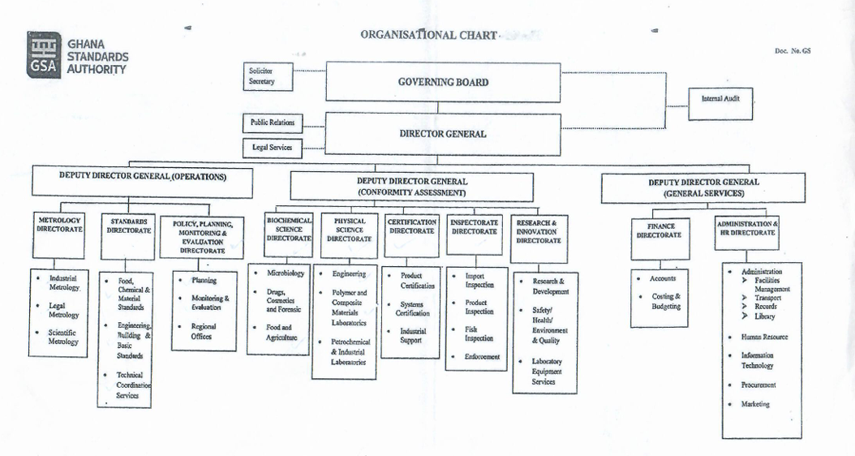

2.3 Classes and Types of information

List of various classes of information in the custody of Ghana Standards Authority:
- Financial Reports.
- Employee Personal Information.
- Inspection Reports.
- Certification Reports.
- Standards Information.
- Metrology Information.
- Testing Reports.

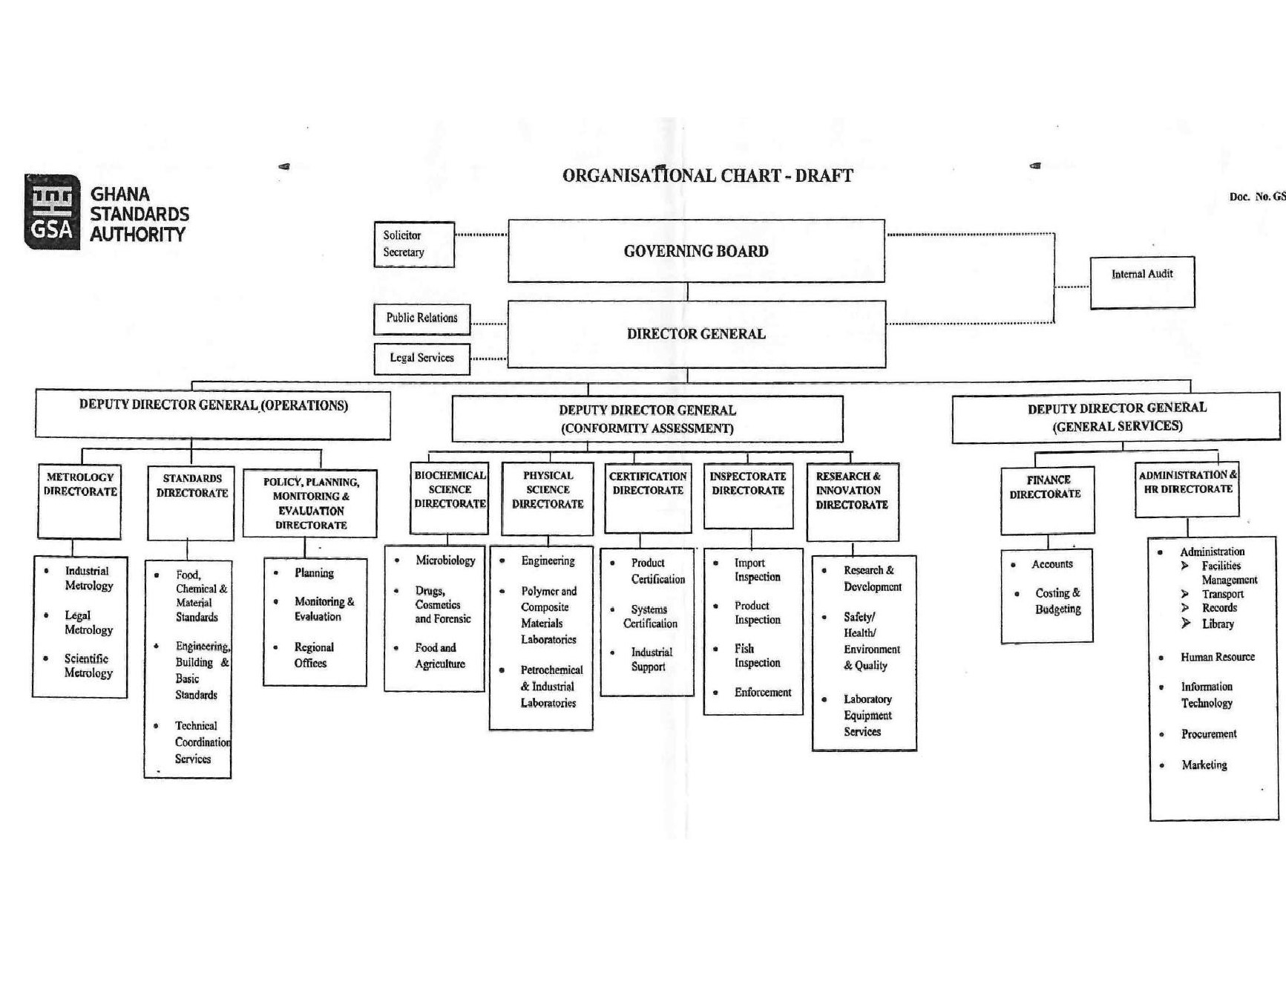
Procedure in Applying and Processing Requests
GS
Section 18 of the RTI Act provides specific guidelines for application for access to information kept by a public institution. It is thus important that request for information is made in accordance with provisions under this Act. The Information Officer is responsible for dealing with applications made to the Ghana Standards Authority. To requests for information under the RTI Act from the Ghana Standards Authority, applicants are to follow these basic procedures:

3.1 The Application Process
- Application by any person or organization who seeks access to information in the custody of Ghana Standards Authority must be made in writing or by using the standard RTI Application Form. (See Appendix A for the Standard RTI Application Form). A copy of the form can be downloaded, completed and submitted electronically via the designated RTI Mail (rti@gsa.gov.gh). The application can also be submitted in-person at the RTI Unit of the Ghana Standards Authority.

- In making the request, the following information must be provided:
- Date of the Application.
- Name of the applicant or the person on whose behalf an application is being made.
- Name of the organization represented by the applicant.
- Available contact details of the applicant or address of the person/organization on whose behalf an application is being made (Telephone Number, Email, Postal Address, Fax).
- Brief description of information being sought. (Applicants are to specify the class and type of information including cover dates).
- Payment of relevant fee if applicable.
- Signature/ thumbprint.

- Provision of identification
The applicant must present at least one (1) of the following valid identification cards (IDs) to serve as proof of identity:
- Driver’s License.
- Passport.
- National ID (Ghana Card).
- Voter’s ID.
- The applicant should state the format of information being requested and the mode of transmission. Example (do you need certified true copy, normal photocopy or electronic copies. Would you want to receive it through a postal address, e-mail, courier services, fax etc.?)

- Where an applicant cannot write due to illiteracy or a disability, he/she may make the request orally. However, oral request must conform to the following guidelines;
- The Information Officer must reduce the oral request into writing and give a copy of the written request as recorded for the applicant to authenticate. (s. 18) (3).
- The Information Officer shall clearly and correctly read and explain the written request to the understanding of the applicant.
- A witness must endorse the face of the request with the writing; “the request was read to the applicant in the language the applicant understand and the applicant understand the content of the request.”
- The applicant must then make a thumbprint or mark on the request.

3.2 Processing the Application
- Applications would be treated on a priority basis. The Information Officer is responsible for handling requests to ensure that statutory deadlines are met.
- Reviews and identify which part is exempt based on Sections 5 to 16 of the RTI Act and determines which of the units in the institution have the records or is responsible for the subject matter of the request.

- Provision is made under section 20 for the transfer of an application within a period of not more than ten days of receipt where the public institution to which the application was initially made is unable to deal with the application. In such situations, applicants would be notified accordingly with the reasons and dates of transfer.

- For information readily available in official publications, the Information Officer shall direct the applicant to the institution having custody of that publication and notify the public institution of the request. (s.21).

- If a requested information is not readily accessible, the estimated time it will take to search for the information would be communicated to the applicant.

3.3 Response to Applicants
- The Information Officer is required under section 23 of the RTI Act to notify applicants within fourteen (14) days from the date of receipt. Applicants should however note that the time limit does not apply to applications transferred to another public institution or which has been refused due to failure to pay prescribed deposit or fee. (s.23) (6). The notice should state:
- Whether or not full access to the requested information will be granted or only a part can be given and the reason for that decision.

- The format and mode of access.

- The expected publication or submission day of the information in the case of a deferred access.

- The prescribed fee (s.24).
b. The Information Officer can request an extension to the deadline if:
- Information requested is voluminous.
- It is necessary to search through a large number of records.
- The information has to be gathered from more than one source.
- Consultation with someone outside the institution is required.

c. The Information Officer would in such situations notify applicants of an extension as well as the period and reason for the extension. An extension should not be more than seven days.
d. In giving applicants access to information, the applicant would be given the opportunity to inspect the information or receive a copy physically or any other form required such as electronic, magnetic, optical or otherwise, including a computer print-out, various computer storage devices and web portals.
- Where access cannot be given in the form specified by the applicant, access can be given in some other form. In such cases, the applicant shall be provided with a reason why access cannot be given in the specified form.

Amendment of Personal Record
A person given access to information contained in records of a public institution may apply for an amendment of the information if the information represents the personal records of that person and in the person’s opinion, the information is incorrect, misleading, incomplete or out of date.

4.1 How to apply for an Amendment
- The application should be in writing indicating;
- Name and proof of identity.
- Particulars that will enable the records of the public institution identify the applicant.
- The incorrect, misleading, incomplete or the out of date information in the record.
- Signature of the applicant.
- For incomplete information claimed or out of date records, the application should be accompanied with the relevant information which the applicant considers necessary to complete the records.

- The address to which a notice shall be sent should be indicated.

- The application can then be submitted at the office of the public institution.

Appendix A: Standard RTI Request Form
[Reference No.: ………………………….]

APPLICATION FOR ACCESS TO INFORMATION UNDER THE RIGHT TO INFORMATION ACT, 2019 (ACT 989)

 | Name of Applicant:
2. | Date:
3. | Name of Institution:
4. | Date of Birth: |  | DD |  |  | MM |  | YYYY
5. | Type of Applicant: |  | Individual Organization/Institution
6. | Tax Identification Number
7. | If Represented, Name of Person Being Represented:
7 (a). | Capacity of Representative:
8. | Type of Identification: National ID Card Passport Voter’s ID  Driver’s License
8 (a). | Id. No.:
9. | Description of the Information being sought (specify the type and class of information including cover dates. Kindly fill multiple applications for multiple requests):
10. | Manner of Access: |  |  | Inspection of Information  Copy of Information  Viewing / Listen  Written Transcript  Translated (specify language)
10 (a). | Form of Access: |  |  | Hard copy Electronic copy Braille
11. | Contact Details: |  |  | Email Address__________________________________  Postal Address_________________________________  Tel: _________________________________________
12. | Applicant’s signature/thumbprint:
13. | Signature of Witness (where applicable)  “This request was read to the applicant in the language the applicant understands and the applicant appeared to have understood the content of the request.”

Appendix B: Contact Details of GSA’s Information Unit

Name of Information/Designated Officer:
Kofi Yeboah Debrah – Head, PR
Nathaniel Kofi Afram – RTI Officer

Telephone/Mobile number of Information Unit:
0242177775
0572851955

Email:

Postal Address of the institution:
P. O. Box MB 245 Accra.

Appendix C: Acronyms
Table 1 Acronyms
Acronym | Literal Translation
RTI | Right to Information
MDA | Ministries, Departments and Agencies
s. | section
MMDAs | Metropolitan, Municipal and District Assemblies
GSA | Ghana Standards Authority
IEC | International Electrotechnical Commission
ISO | International Organization for Standardization
NRCD | National Redemption Council Decree

FEES AND CHARGES

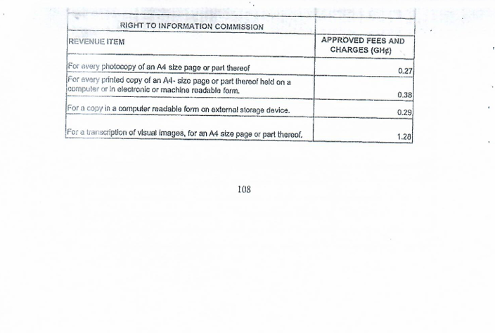

FEES & CHARGES

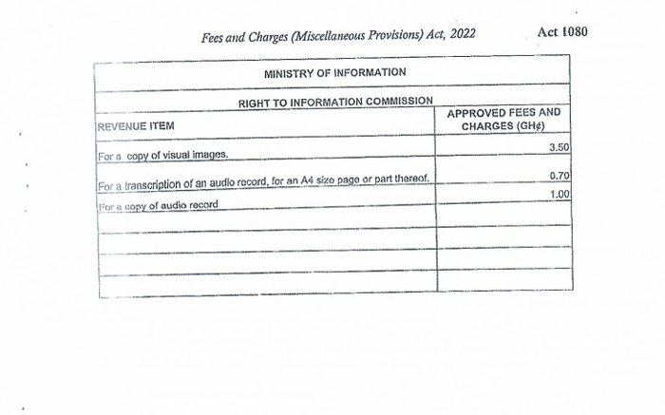

9.Appendix D: Glossary
This Glossary presents clear and concise definitions for terms used in this manual that may be unfamiliar to readers listed in alphabetical order. Definitions for terms are based on section 84 of the RTI Act.
Table 2 Glossary
Term | Definition
Access | Right to Information
Access to information | Right to obtain information from public institutions
Contact details | Information by which an applicant and an Information Officer may be contacted
Court | A court of competent jurisdiction
Designated officer | An officer designated for the purposes of the Act who perform similar role as the Information Officer
Exempt information | Information which falls within any of the exemptions specified in sections 5 to 16 of the Act
Function | Powers and duties
Government | Any authority by which the executive authority of the Republic of Ghana is duly exercised
Information | Information according to the Act includes recorded matter or material regardless of form or medium in the possession or under the control or custody of a public institution whether or not it was created by the public institution, and in the case of a private body, relates to the performance of a public function.
Information officer | The information officer of a public institution or the officer designated to whom an application is made
Public | Used throughout this document to refer to a person who requires and/or has acquired access to information.
Public institution | Includes a private institution or organization that receives public resources or provides a public function
Right to information | The right assigned to access information
Section | Different parts of the RTI Act

